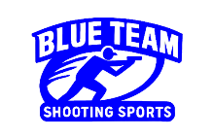Stage 1 – Does your shootin iron work?
COURSE DESIGNER: Ike Starnes (Stolen from Zoo City)
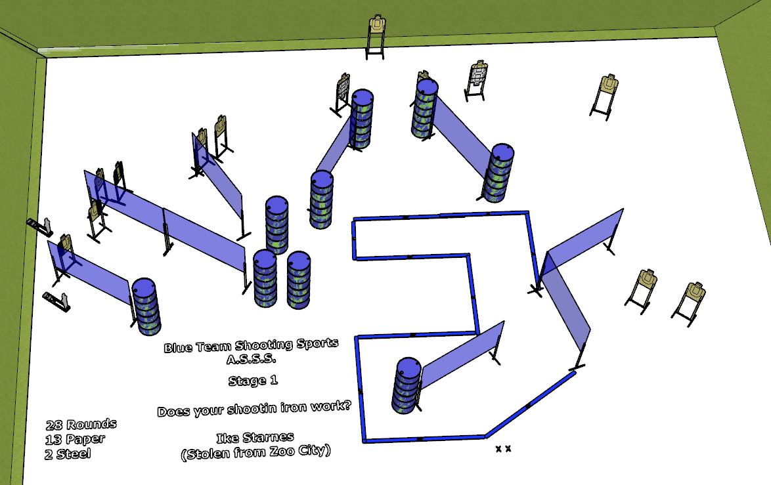

Written Stage Briefing:
Stage 1 – Does your shootin iron work? is a 28 round, 140 point, Comstock course. There are 13 cardboard targets and 2 steel targets. The best 2 hits per cardboard target will be scored. The steel must fall to score.
Start position Both feet on the Shooting Sports Innovations Xs.
Handgun: Loaded and holstered, wrists below belt
PCC: Loaded, stock touching belt
On the audible start signal, engage targets from within the shooting area.

